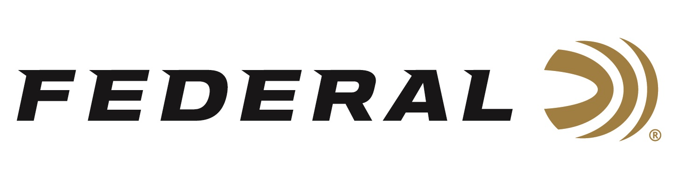

FOR IMMEDIATE RELEASE

Federal Ammunition Sponsored Shooters Shine at Skeet Trials

ANOKA, Minnesota – September 26, 2019 – Federal Ammunition sponsored shooters are in good position after Part 1 of the 2020 Olympic Shotgun Trials over the weekend in Kerrville, TX. Competing for the coveted skeet spots on team U.S.A were Vincent Hancock and Caitlin Connor.

In the men’s skeet finals, two-time Olympic gold medalist Vincent Hancock defeated Phillip Jungman to finish the competition with a slim one-point margin ahead of Jungman. Hancock says the field competing for the team performed at a high level. “Once in the Final, I started to shoot like myself again and felt great throughout the round,” says the three-time Olympic qualifier. Hancock finished with a 59/60 in the final which allows him to gain a few crucial targets over the field at the next match.

Competing on the women’s side, Caitlin Connor, 2018 World Champion, finished with a strong performance while trying to qualify for the Tokyo games. Connor placed third in the finals and tied for fifth place overall in the women’s skeet standings. Connor finished with 236 points over the four days of competition at the Hill Country Shooting Sports Center in Kerrville, TX. The final qualifying leg of the Olympic trials well be held February 25-March 8, 2020 in Tucson, AZ as part of the Shotgun Spring Selection.

Federal is the official shotshell ammunition sponsor and supplier of USA Shooting, a non-profit organization that promotes the shooting sports and prepares American athletes to bring home gold. Learn more about USA Shooting at: www.usashooting.org.

For more information on Federal ammunition, visit www.federalpremium.com.

Press Release Contact: JJ Reich
Senior Communications Manager - Firearms and Ammunition
E-mail: VistaPressroom@VistaOutdoor.com

About Federal Ammunition
Federal, headquartered in Anoka, MN, is a brand of Vista Outdoor Inc., an outdoor sports and recreation company. From humble beginnings nestled among the lakes and woods of Minnesota, Federal Ammunition has evolved into one of the world's largest producers of sporting ammunition. Beginning in 1922, founding president, Charles L. Horn, paved the way for our success. Today, Federal carries on Horn's vision for quality products and service with the next generation of outdoorsmen and women. We maintain our position as experts in the science of ammunition production. Every day we manufacture products to enhance our customers' shooting experience while partnering with the conservation organizations that protect and support our outdoor heritage. We offer thousands of options in our Federal Premium and Federal® lines-it's what makes us the most complete ammunition company in the business and provides our customers with a choice no matter their pursuit.

